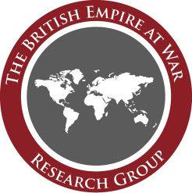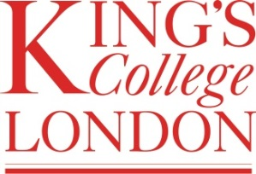

The British Empire at War Research Group
The Dominions and the Second World War
The Mawby Room, Kellogg College Oxford, 0930-1730 4 April 2013

0930 Arrival
1000 Welcome from Jonathan Fennell, Ashley Jackson, and Yasmin Khan
1010 Iain Johnston (Cambridge), ‘The Contribution of the Dominions, 1939-1945’ (paper presented in absentia)
1030 Kent Fedorowich (University of the West of England), ‘Anglo-Dominion Relations and the Failed Imperial Conference of 1941’
1100 Coffee
1130 Carl Bridge (King’s College London), ‘The Australia-New Zealand Agreement of January 1944: Another Look’
1200 Jonathan Fennell (King’s College London), ‘The New Zealand Army and the Furlough Mutinies, 1943-1944’
1230 James Watson (Massey), ‘Reconsidering “the Protein Bridge”: New Zealand’s Reluctant Involvement in the War against Germany (1939-40) and its Role in Supplying the United Kingdom with Food and Fibre’
1300 Buffet lunch
1345 Doug Delaney (RMC Canada), ‘Imperial Armies: Britain and the Land Forces of the Dominions, 1902-1945’ (paper presented in absentia)
1415 David Whittington (University of the West of England), ‘Amery, India, and the Second World War: The Dominion that Never Was’
1445 Michael Kennedy (Royal Irish Academy), ‘The Neutral Dominion: Ireland during the War’
1515 Donal Lowry (Oxford Brookes), ‘The Impact of Irish Neutrality on Afrikaner Nationalists in South Africa’
1545 Tea
1600 Andrew Stewart (King’s College London), ‘Empires Found: Reflections on Second World War History’
1615 Plenary discussion led by Carl Bridge and Kent Fedorowich (refer to ‘Agenda’ overleaf)
1730 Pub

Towards an agenda

This workshop will explore the individual and collective experiences of the Dominions in the Second World War. By bringing together a small group of scholars on the subject, it aims to generate a richly empirical cross-national understanding of events in order to identify common patterns and differences in the ways in which the Dominions coped with the challenges posed by the Second World War.

Specifically, the workshop seeks to locate this discourse in the context of broader narratives and historiographies:

- How did issues relating to the home front, politics and strategy impact upon the Dominion forces engaged against the Axis?
- What can the experience of Dominion citizens in the Second World War teach us about the political, social and economic realities of pre-war Dominion societies?
- To what extent did the experience of war impact on political, social and economic change post-war?
- How were the varying Dominion societies reflected in the ethos and functioning of their armies? (from David McIntyre)

It is hoped that lively discussion will ensure the emergence of fresh insights, not only into the experience of war in the Dominions, but also into the dynamics that shaped post-war society.

Also in attendance: Alex May, Gajendra Singh, Alex Wilson, Tom Buchanan, Daniel Lear, Ben Mountford
Supportive from afar: Alan Jeffreys, Bill Nasson, Neil Roos, Rob Johnson, Jeffrey Grey, W. David McIntyre, John Crawford, Greg Kennedy, Jonathan Vance, Kate O’Malley, Douglas Ford, Catherine Wilson, Niall Barr, James Belich, Richard Bosworth, Joe Maiolo, James Curran

This event is supported by Kellogg College Oxford, the Arts & Humanities Research Council, the British Empire at War Research Group, and King’s College London

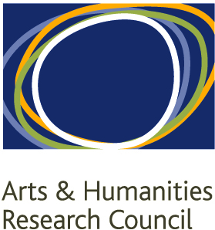

http://britishempireatwar.org

